Year 7 Music Test

Link the key words on the left below to the correct definition on the right.

|  |  |  |
| --- | --- | --- |
| Sound |  | How something sounds |
|  |  |  |
| Music |  | Expression without words |
|  |  |  |
| Timbre |  | Happy key |
|  |  |  |
| Rhythm |  | Vibrating air |
|  |  |  |
| Ostinato |  | Sad key |
|  |  |  |
| Syncopation |  | Fast or Slow |
|  |  |  |
| Melody |  | Off-beat rhythm |
|  |  |  |
| Major |  | Organised sound |
|  |  |  |
| Minor |  | Loud or quiet |
|  |  |  |
| Dynamics |  | Repeated pattern |
|  |  |  |
| Texture |  | Organised sound in time |
|  |  |  |
| Tempo |  | Layers of sound |

2. If you start on a C on the keyboard and went up an octave, what note would you land on?

_______________

3. Using the techniques taught in class, label the notes below:

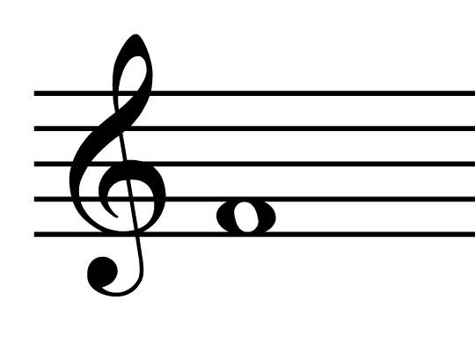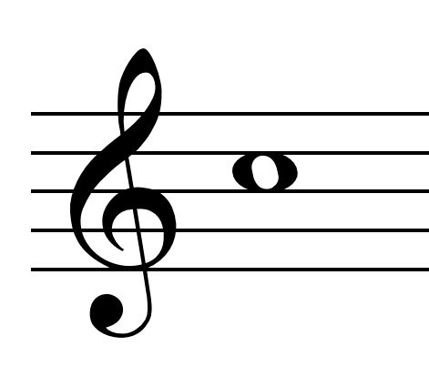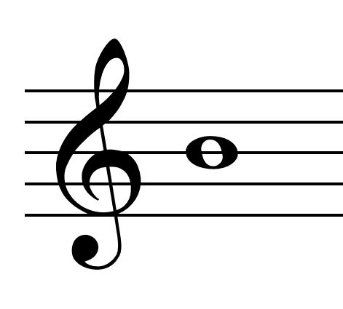

__ __ __

Below are a selection of rhythm values. How many beats is each one worth? An example is provided.

[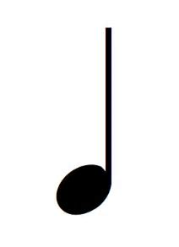](https://www.bing.com/images/search?view=detailV2&ccid=+5kraSNP&id=EE21B6F104FBC9517E140C98D0833C59E189F79B&thid=OIP.-5kraSNPLysghHCbUCJp-gDUEl&mediaurl=https://liveandbreathemusic.files.wordpress.com/2014/07/crotchet.png&exph=380&expw=275&q=+crotchet&simid=608020994482769527&selectedIndex=0)= 1 beat [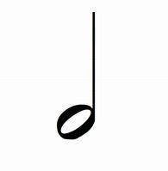](https://www.bing.com/images/search?view=detailV2&ccid=vzrc0TQf&id=DCD3E6541E2ABDF62A64349B5CD5DFB513050CE7&thid=OIP.vzrc0TQfOeLMxz1Pv5oAhAHaHa&mediaurl=http://www.quia.com/files/quia/users/kalindajade/Minim&exph=300&expw=300&q=minim&simid=608046777177343762&selectedIndex=1)=___ beats [](https://www.bing.com/images/search?view=detailV2&ccid=+O0a5+cn&id=13190D7937287F5DDF6C7BB8E1EA2497118A10F6&thid=OIP.-O0a5-cntJCoa_88vcLxKAHaO0&mediaurl=https://upload.wikimedia.org/wikipedia/commons/thumb/4/4a/1-1_note_semibreve.svg/512px-1-1_note_semibreve.svg.png&exph=1024&expw=512&q=semibreve&simid=608008835448703903&selectedIndex=3) =___ beats 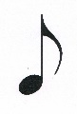=___ beat